Requirements Analysis Document

Application: Citicide

Date: 13/02/2020

Index

1. Introduction 3
1.1 Purpose of the system 3
1.2 Scope of the system 3
1.3 Objectives and success criteria of the project 3
1.4 Definitions, Acronyms, and abbreviations 3
2. System Description 4
2.1 Functional Requirements 4
2.2 Non-functional Requirements 4
3. Use Cases 5
3.1 Use Case diagram 5
3.2 Use case descriptions 5
3.2.1 Use Case <name> 5
4. Mockups 6

1. Introduction

1.1 Purpose of the system
The application “Citicide” allows citizens to create and vote Infrastructure and Social projects, so they can be part of the decisions which are made to improve their countries and solve international problems. Citizens, in the following lines called users, can vote individually and be part of different groups for supporting all together a project.
This is a very useful application, since it provides users the freedom to propose and vote different projects, and by this way they have the feeling of being part of the decisions that are made around their lives.

1.2 Scope of the system
The application “Citicide” should be able to hold on online a lot of people from all around the world.
It should be capable of letting the users create as many groups as they want, but not letting them to be at a subgroup if they are already on a group that is above or below that one. The user must be registered if he wants to access the platform. Also, he can log in and log out as many times as he wants but if he fails on entering the password 5 times, he will need to change it.

1.3 Objectives and success criteria of the project
The success of the application depends upon meeting the following core set of objectives:
- Users must have an easy experience for signing up.
- When logging in, users should be capable to create/join any group, not for subgroups (as explained before).
- Apart from groups, this program also aims to generate real projects that will be send to the external association, asking for a welfare fund.
- As we believe in a democratic application, we want that everyone can vote for a project, also a group owner can vote in name of the whole group.

Our main goal is to create a steady system, in which the future enhance tasks would be developed in the best way, also we desire to create a system capable to support different modules including a GUI, where all possible users would feel comfortable.

In order to do so, we will test each module separately and at the end we are going to do a deep unitary test for all the application, with all those tests we will ensure the proper functioning of the whole system.

1.4 Definitions, Acronyms, and abbreviations
Administrator Person who controls what happens in the application. He is the responsible of admitting or rejecting new projects and determine how many votes does they need to be sent to the external association. He can also ban users giving them a reason and unban them as well.

User Person that has created an account on “Citicide”. There are two type of users:
- Manager: Creator of a group.
- Proponent: Creator of a project.

Ban Action that the administrator can take on a user that has not behave properly in agreement with the rules of the application.

Group A collective of users that has a topic in common. A user can subscribe a group if it is of his interest, as well as he can unsubscribe. A manager of a group can create a project. That project will be supported by all the members of the group. The manager can also vote for a project that he thinks the group will be in favor of.

Subgroup Groups inside other groups. If a user wants to be part of more than one subgroup, he can only pick subgroups that are on the same depth level.

Project An idea that a user or a group has, and they want to accomplish it. There are two types of projects:
- Infrastructure: Construction that citizens want to be built in a certain district.
- Social project: Proposal that can be national or international, for helping a specific society group.

Votes Numbers of users in favor of that project for taking it as a proposal for the City Hall.
Reports There are two type of reports:
- Popularity reports: Contains the number of votes that a project has. It can only be seen by the users who have already voted.
- Affinity reports: Number of common projects a group has with another one. This report is calculated by doing the number of people that are in each group and support the projects founded by the other group, and the other way around. Then divide this number by the total number of users in both groups. (N12+N21)/(N1+N2)

2. System Description

2.1 Functional Requirements
- You should be registered to enter the platform. If you are not, you can only register.
- The only person who can ban a user or approves projects requested by other users is an administrator of the application.
- The system should be able to register a person just once, and if the person it is not banned.
- The application must hide the information of the users. You can only see the groups other users are in.

- Groups are done by a user. Once a user has created a group, he is a manager. He, and only he, can create another subgroup (there is no limit for how many subgroups you can create).
- A user can be the manager of several groups (there is no limit)
- There is no chat in the group.
- It should be capable of letting the users create as many groups as they want, but not
letting them to be at a subgroup if they are already on a group that is above that one.
- The manager of a group cannot delete another user from that group. The users can only unsubscribe from them.
- If a manager of a group gets banned nothing happens. He will still be in their group description, because he could be unbanned in the future.

- When a project created from a group or from a user gets approved or rejected you get a notification. The manager will always receive the notifications. The members of the group should turn on the notifications.
- The user who creates a project becomes a proponent.

- The users must create projects that will help the community.
- There are two types of projects:
· Infrastructure and Social projects.
- Once you vote on a project as an individual or as a group representant, you cannot unvote.
- The votes can be individual or done by a manager of a group. If it is done as a manager, he must specify which group is he voting for.
- If you are in a group and the manager votes for a project, you can leave the group for unvote.
- If you want to see the number of votes a project has, you need to have voted that project.
- If you are banned, all the projects you have voted, lose a point.

-There are reports:
· Popularity reports: Can be seen only if the user is supporting the project, the report contains only the number of votes.
· Affinity reports: Number of common projects supported by groups, only users who belongs to both groups can see them

- We search projects (the owner can check the status with the ID) and groups by name

2.2 Non-functional Requirements
- Operational: Saving the information of the application in a server: Every 30s.
- Security: You can log in and log out as many times as you want but if you fail on entering the password 5 times you will need to change it.
- Resources: Memory (Database): 100 Terabyte.
- Performance: Response time for every button: less than 0’5ms
Numbers of users: 1’95 billions.
Text: Must be clear and visible from at least 30cm.

- Registration: You must provide an ID, a NIF (with 9 characters) and a password.
- The users can have a state.
- They only can see the IDs of other users, but not their NIF or password.

- Groups (public): It must have a name, the manager of that group and can have a description.

- Projects:
· Infrastructure: It must have a title of 25 char maximum (there can be projects with the same name), a description with 500 maximum, district, a drawing, the city hall ID, a minimum number of votes, amount of money requested and the amount of money granted after having the minimum votes. If the project has been rejected or accepted.
· Social Projects: Specify if they are national or international, title of 25 chars max, a description of 500 characters max, the group of people the project is addressed to with a maximum of 50 characters, the city hall ID, a minimum number of votes, amount of money requested and the amount of money granted after having the minimum votes. If the project has been rejected or accepted.
- The minimum number of votes for approving a project is set by the administrator. After that it cannot be changed.
- The state of a project can be checked with its ID (unique)
- If a project is not approved by the administrator, he can give a reason using 50 chars.
- If a project does not have the minimum number of votes to get founded for 30 days
since the project is approved by the administrator, it gets expired.
- The minimum number of votes of a project, can only be seen by the manager of a
group or individual users, once they have vote it.
- When a project receives the minimum number of votes, the representative of the
project submits it to an external organization, it is converted to an id and users can see
how the project is using this id (rejected, approved, …).
- Votes are dynamic, if a group is supporting a project and it is added a new member it
must be summed a vote, and the other way around, if someone unsubscribes or it is
banned (same approach for individual votes), its vote is removed.

- The affinity reports are calculated by doing the number of people that are in each group and support the projects founded by the other group, and the other way around. Then divide this number by the total number of users in both groups. (N12+N21)/(N1+N2).

3. Use Cases

3.1 Use Case diagram

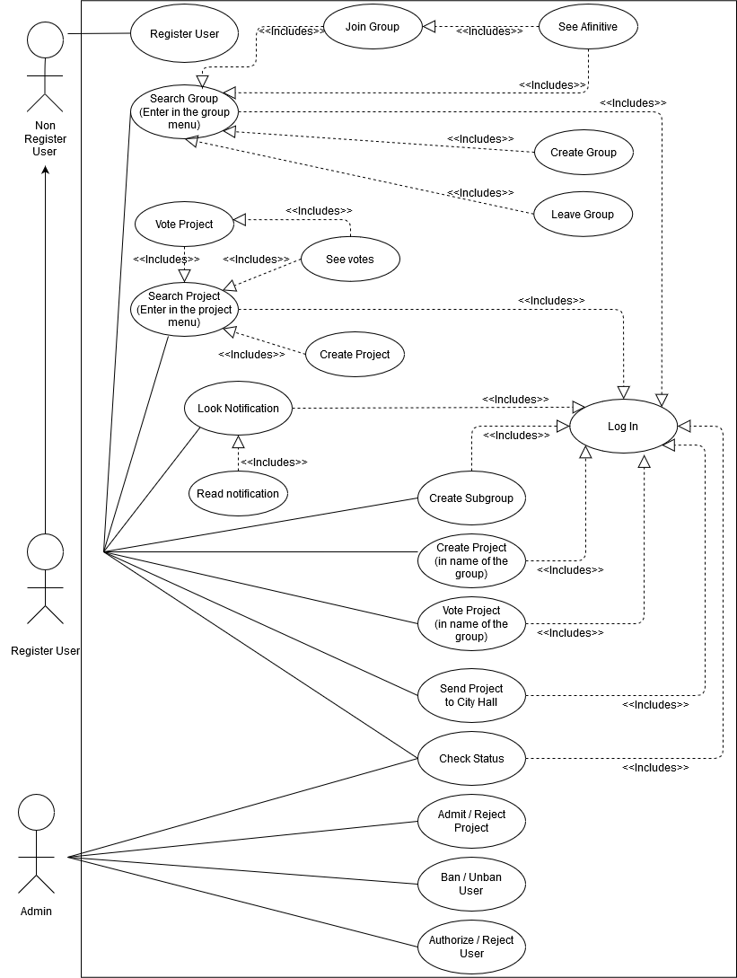

3.2 Use case descriptions
Use Case 3.2.1: Search Group.

Primary actor: Registered User.
Stakeholders and goals:
- Registered User: To enter in the “Group” menu interface, where he can make all the actions related with a group, as individual.
- Administrator: Can check the behavior of the groups to decide whether ban a user or not.
- Group Owner: He can make access all the functions of the group, taking those actions in the name of the whole group.

Preconditions: The user is identified by the log in use case.

Success Guarantee (Postconditions): The user could display all the groups that he belongs to, also he could search new group to log in and access any possible action related with groups management through this menu.
Main Success Scenario:

- The user selects the “Groups” tab.
- The user selects any group (if any) or search a new one.
- The user can join the group.
- The user displays the information of the group.
- The user may look the Affinitive Report associated with this group.
- The user can leave the group.
Extensions (Alternative paths):
    - The user joins a new group.
- The system decides if the user can enter in the group or not.
- The system displays a new group in the current groups list.
    - The user leaves a group.
- The system erases a group from the current group list
    - The user creates a new group.
- The user fulfills the information about the group.
- The system promotes the user from register user to group owner
- The group is included in the data bases and it is ready to anyone that wants to join in.
    - The user can see the affinitive between two groups (only if he belongs to both groups)
- The system displays the affinitive coefficient or an error.

Technology and Data Variations List:
- Option to search new groups.
- Option to display data about the groups that the user belongs to.
- Option to display the affinitive report.
- Option to join/leave groups.

Frequency:
- Very high, in order of hundreds per current users.

Open Issues:
- In a future version the group may be expanded, so it is possible to append new extensions to this main menu.

Use Case 3.2.2: Search Project.

Primary actor: Registered User.
Stakeholders and goals:
- Registered User: To enter in the “Project” menu interface, where he can make all the actions related with a project, as individual.
- Administrator: Must accept or reject a new project, when it is created, also he must decide the minimum number of votes that the project needs in order to be send to the city hall.
- Project Owner: He can send the project to the City Hall, then he can check the status of the project by an Id given by the City Hall.

Preconditions: The user is identified by the log in use case.

Success Guarantee (Postconditions): The user could display all the projects that he has voted, also he could search new project to vote and access any possible action related with project management through this menu (such as see the vote of the project).
Main Success Scenario:

- The user selects the “Projects” tab.
- The user selects any project (if any) or search a new one.
- The user can vote for a project.
- The user displays the information of the project.
- The user may look the Project Report (number of votes) id he has vote for this project as individual.
- The user can create a new project.
Extensions (Alternative paths):
- The user votes for a project.
  - The system updates the number of votes.
- The user creates a new project.
- The user fulfills the information about the project.
- The system sends a message to an administrator to check the project.
- The system promotes the user from register user to project owner.
- The project is included in the data bases and it is ready to anyone that wants to vote for it.
- The user can see number of votes of the project if he has voted for the it as an individual
- The system displays the number of votes or an error message.

Technology and Data Variations List:
- Option to search new projects.
- Option to display data about the project that the user has vote to.
- Option to display the project report.
- Option to vote a project.

Frequency:
- Median, in order of tens per current users.

Open Issues:
- In a future version the group may be expanded, so it is possible to append new extensions to this main menu.

Use Case 3.2.3: Create a Project (in name of a group).

Primary actor: Group Owner.
Stakeholders and goals:
- Group Owner: To enter in the “Project” menu interface, where he can make all the actions related with a project, as a collective leader.
- Administrator: Must accept or reject a new project, when it is created, also he must decide the minimum number of votes that the project needs in order to be send to the city hall.
- Project Owner: He can send the project to the City Hall, then he can check the status of the project by an Id given by the City Hall.

Preconditions: The user is identified by the log in use case.

Success Guarantee (Postconditions): The user create a project, in name of the groups that he own, so the project will have the name of one on the groups and will start with a number of votes equal to the number of votes that the groups that gives the name to the project has

Main Success Scenario:

1. The group owner presses the create project button.
2. The group owner selects the “as group owner” option.
3. The group owner fulfills the info about the project.
4. The group owner waits for the administrator to accept the project.

Extensions (Alternative paths):
In this case, they are not any extension to the use case.
Technology and Data Variations List:
- Option to create a group as collective.

Frequency:
- Very low, in order of one quarter per current users.

Open Issues:
- We do not think, in futures improves in this use case.

4. Mockups
Initial page.

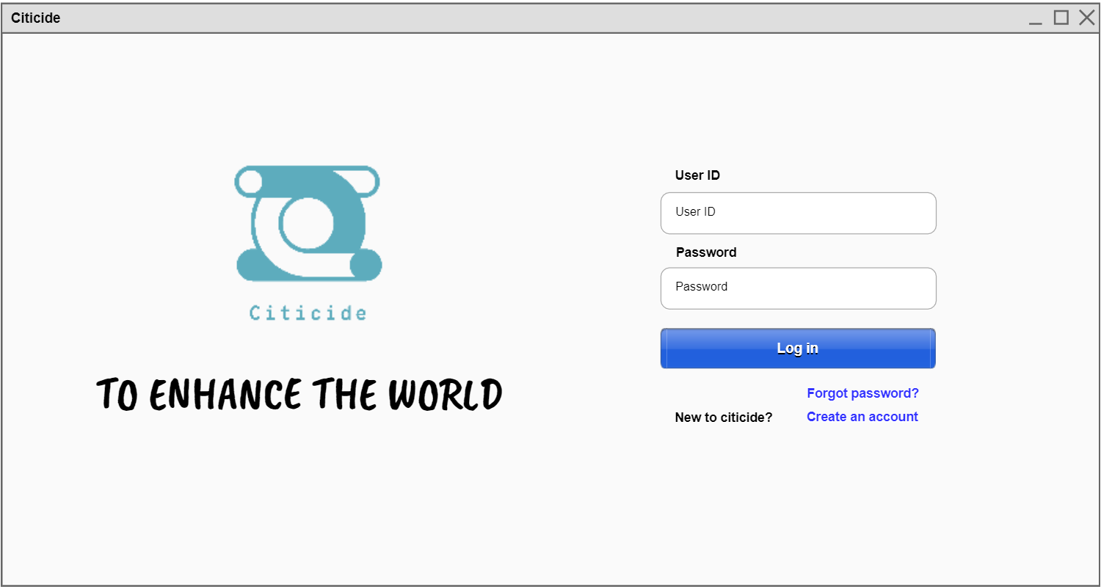
Button
Figure 1

From the initial page (Figure 1) by pressing “Create an account”, we go to the register page.

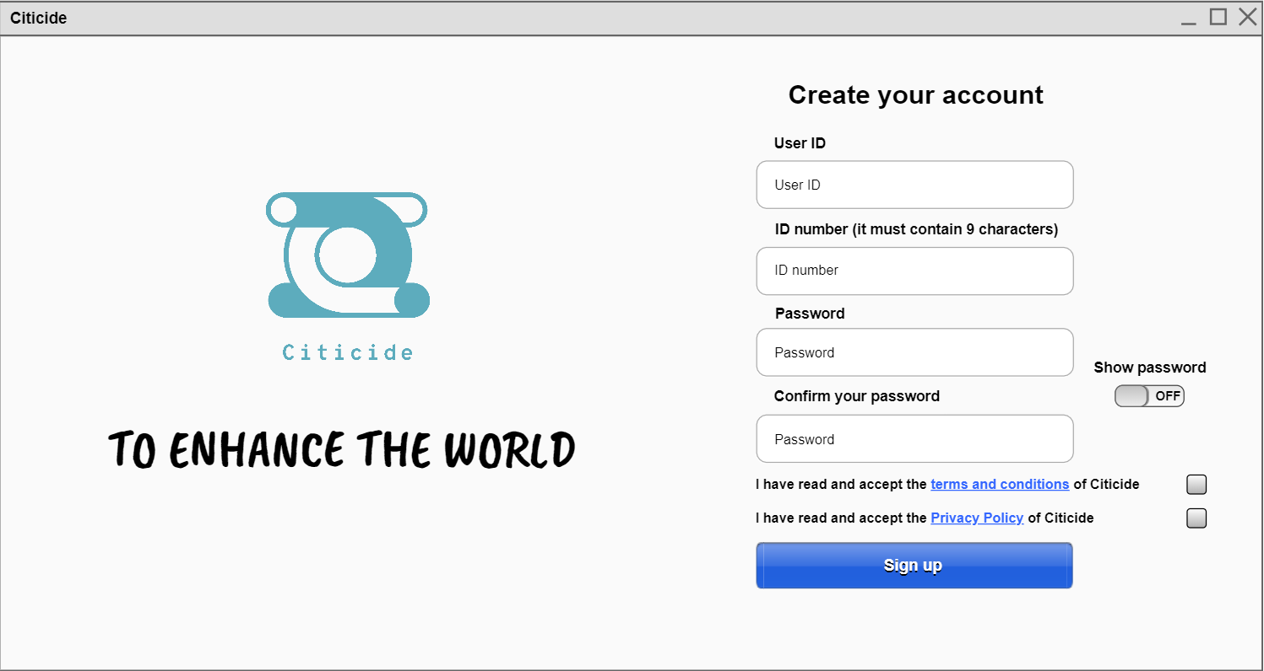
Figure 2
Link to the documents

Note: In all the following figures, the respective list that appears on the left is always shown as long as the option on the combo box is kept selected. This means, those are not the options of the combo box.

From the initial page (Figure 1) by pressing “Log in” or from the register one (Figure 2) by pressing “Sign up” it is shown the groups that the user has. Clicking on the group, its information is displayed. In case the user is not the manager of the group:
Groups that the user has

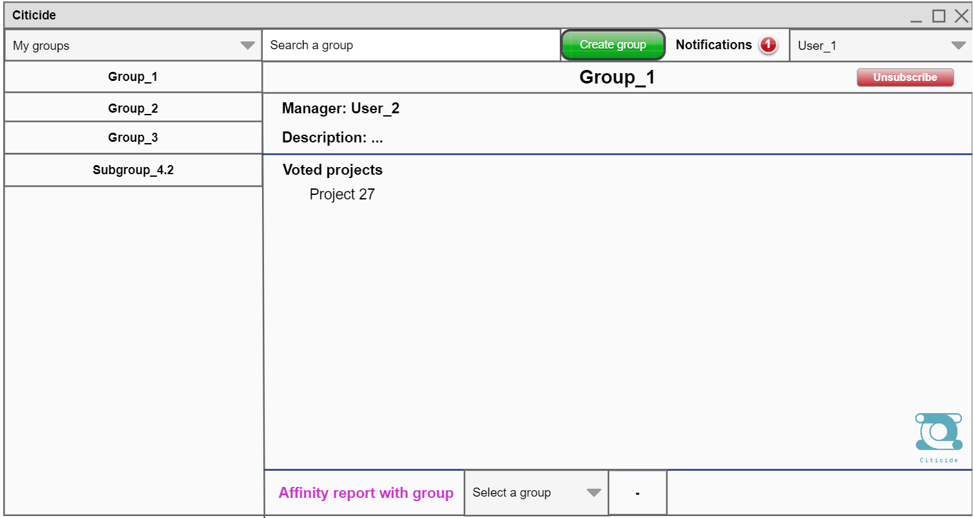
Figure 3.1
Combo boxes
Number of unread notifications
In case the user is the manager of the group:

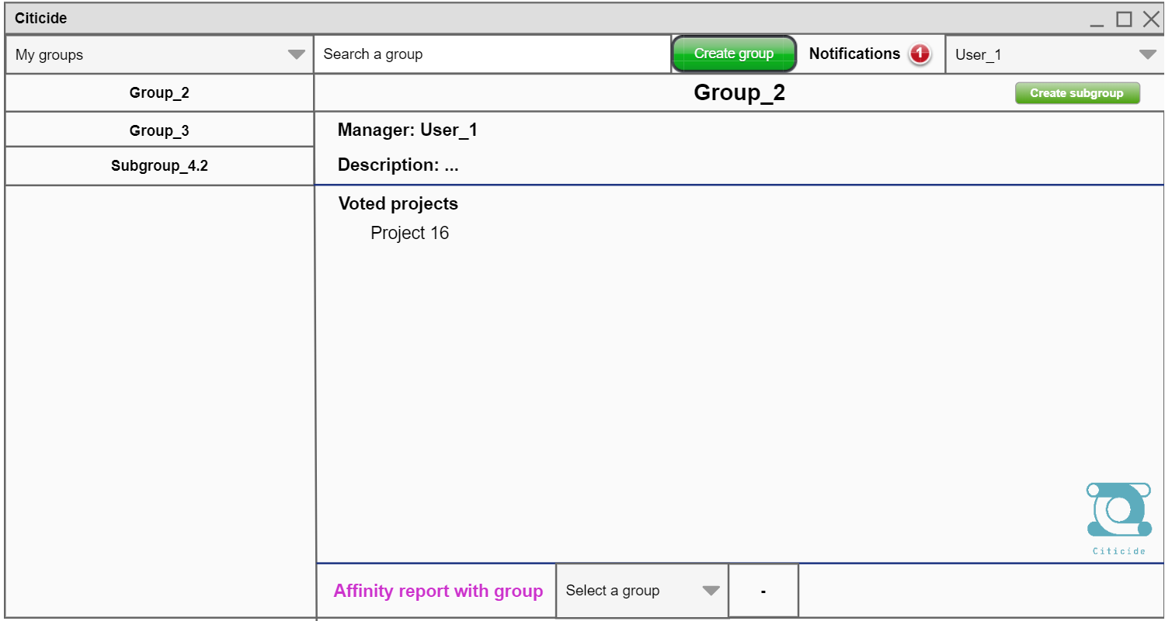
Figure 3.2
Search bar
Place where the affinity report is displayed

If we press “Create group” on Figures 3.1 or 3.2:

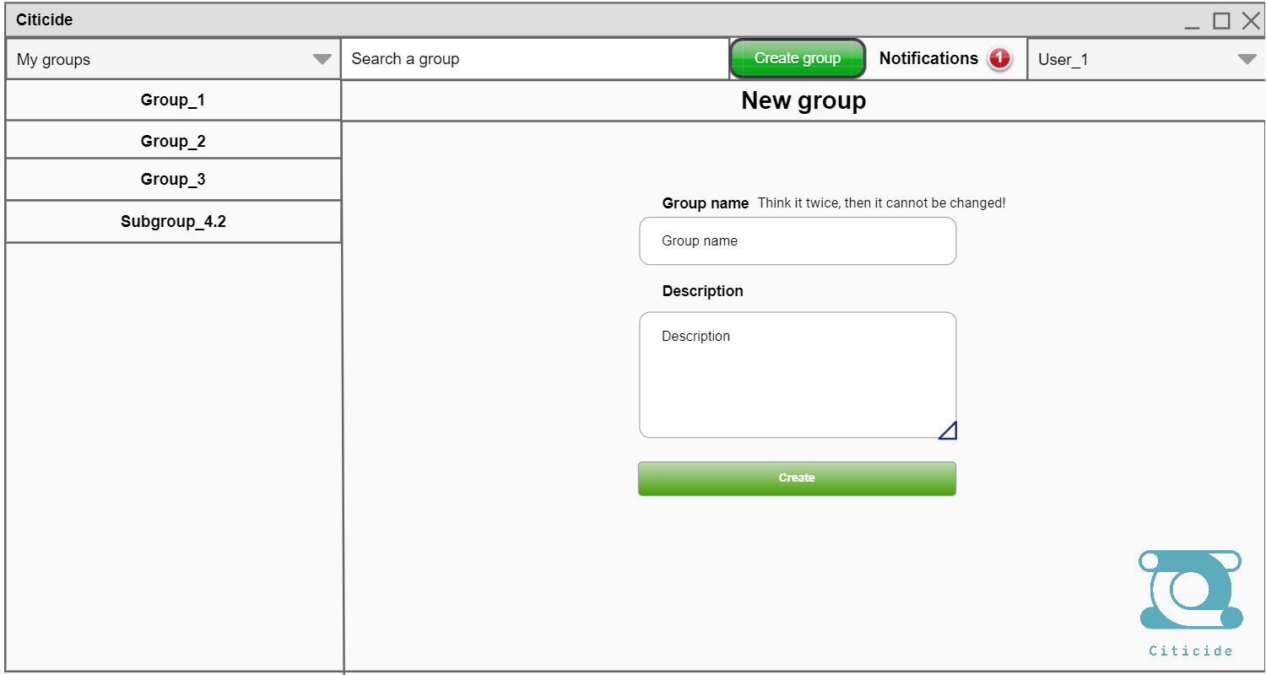
Figure 4
Pressing the triangle and sliding changes the size of the box

Then, if from any of the last three windows (Figures 3.1, 3.2 or 4) we choose in the combo box the option “Projects”, we can see all the available projects, and by clicking on the name its details are shown and the option to vote is given.

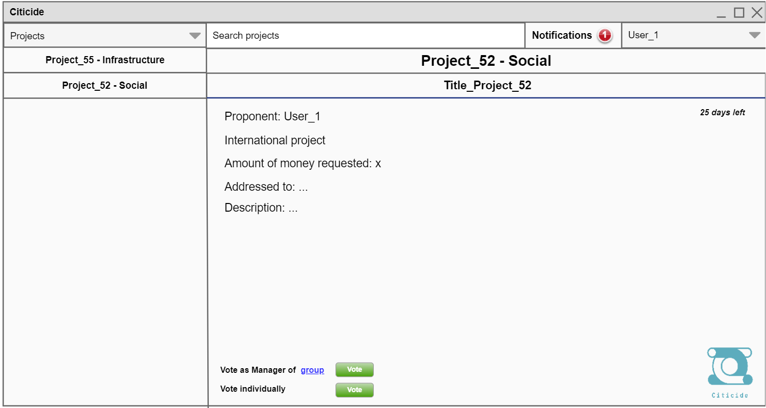
Figure 5

Then, if from any of the last four windows we choose in the combo box the option “My projects - Created”, we can see the projects that we have created with its different details and if we have voted or not. If we have not voted with group yet, in this window we can do it. In case it is an Infrastructure project, the following information is displayed:

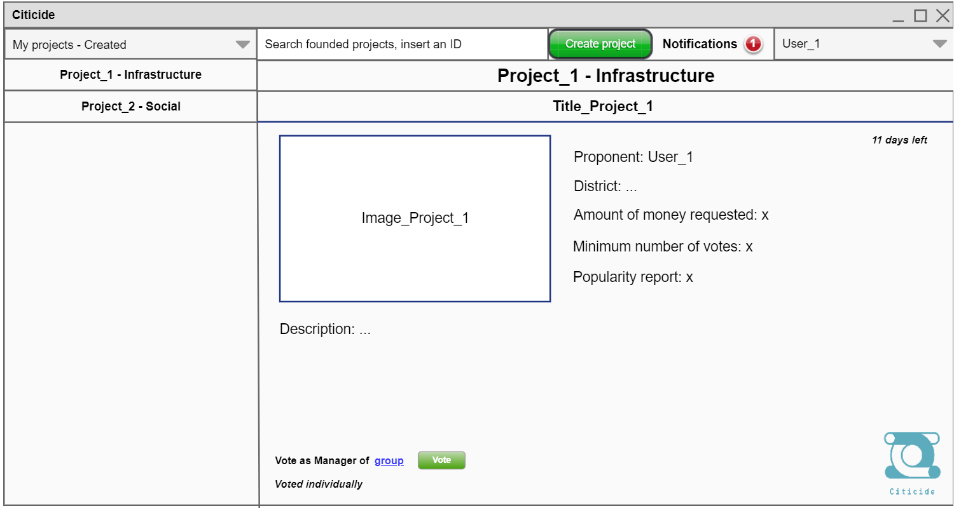
Button for voting after having selected the group
Figure 6.1

In case it is a Social project:

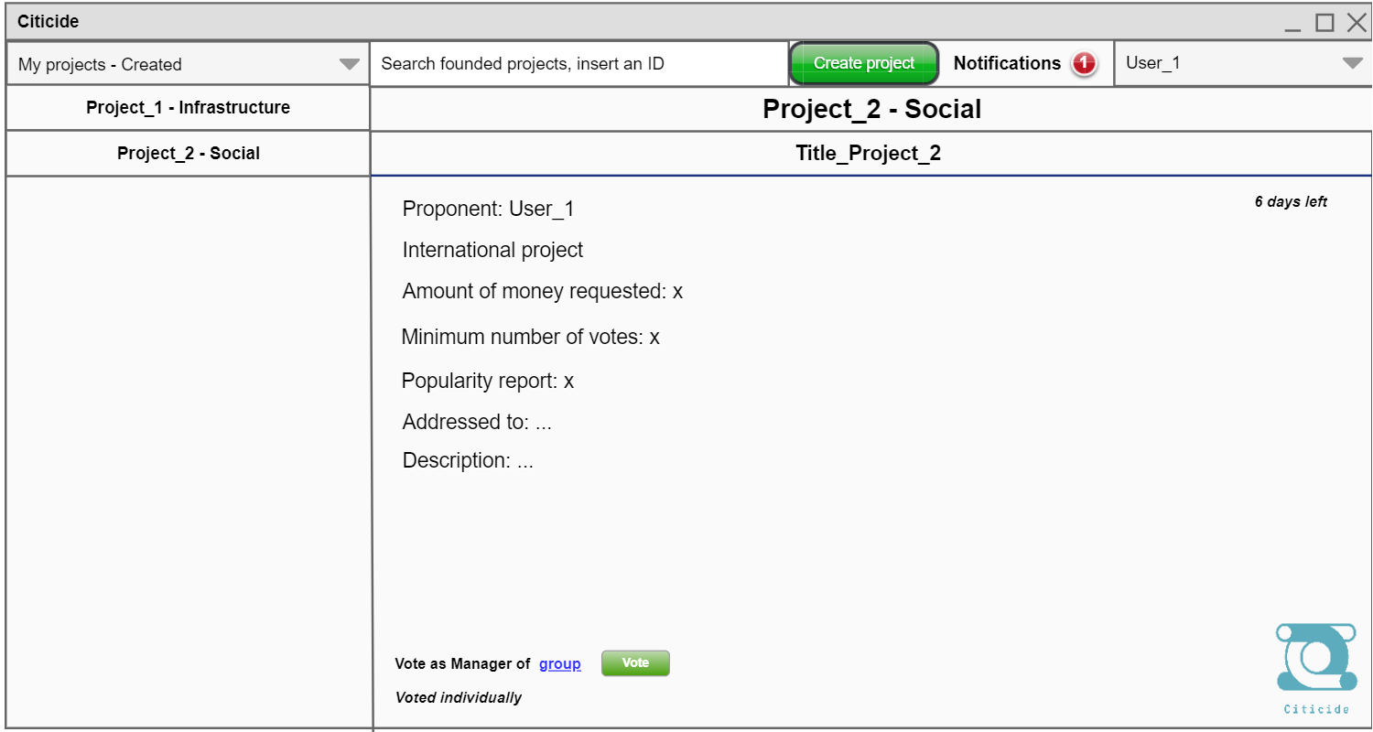
Figure 6.2

If in Figures 5, 6.1 or 6.2 we click on “group” (near the “Vote” button), we can select the group/s that we want to vote for, and the following window appears.

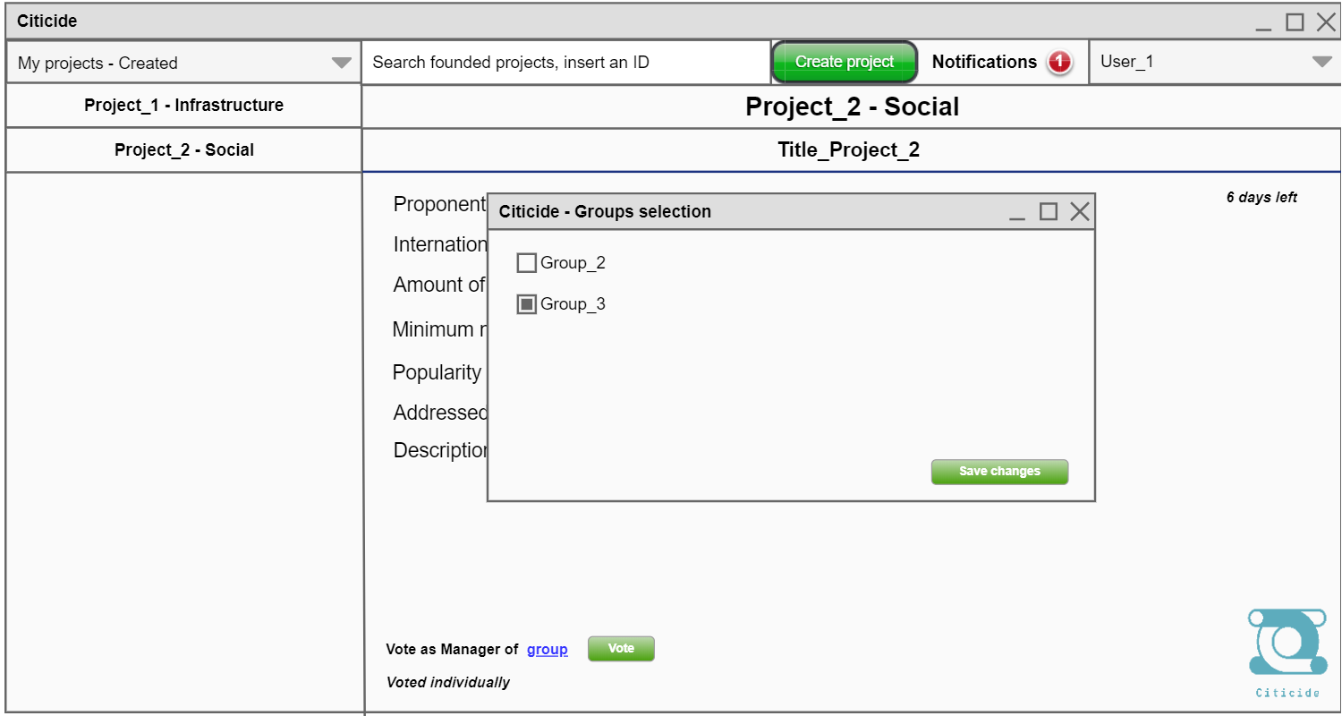
Checkbox
Figure 7

If we want to know the state of a project, we can insert the project ID on the search bar, and we go to the following page.

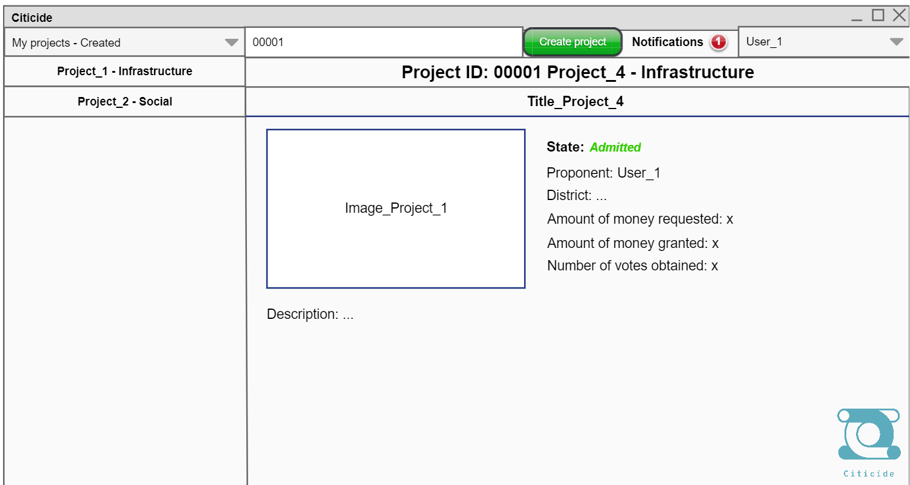
Figure 8

If in Figures 6.1, 6.2, 7 or 8 we press the “Create project” button, we go to the following window, where the we must first select the category of the project and the proponent, which can we us as user or as manager of any of our created groups.

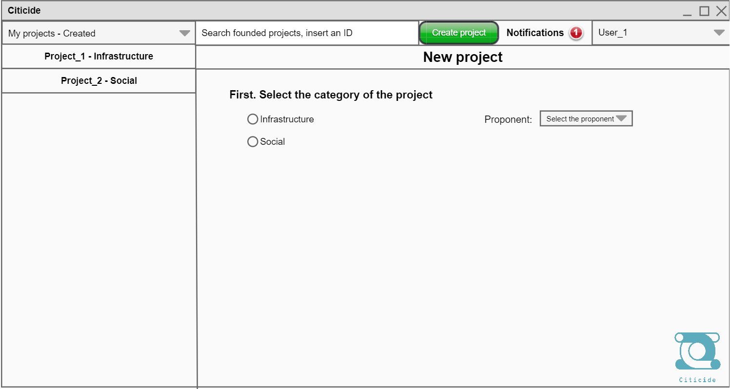
Radiobutton
Combo box for selecting the proponent
Figure 9

If the we select the “Infrastructure” category in Figure 9, the window for filling in the data is displayed:

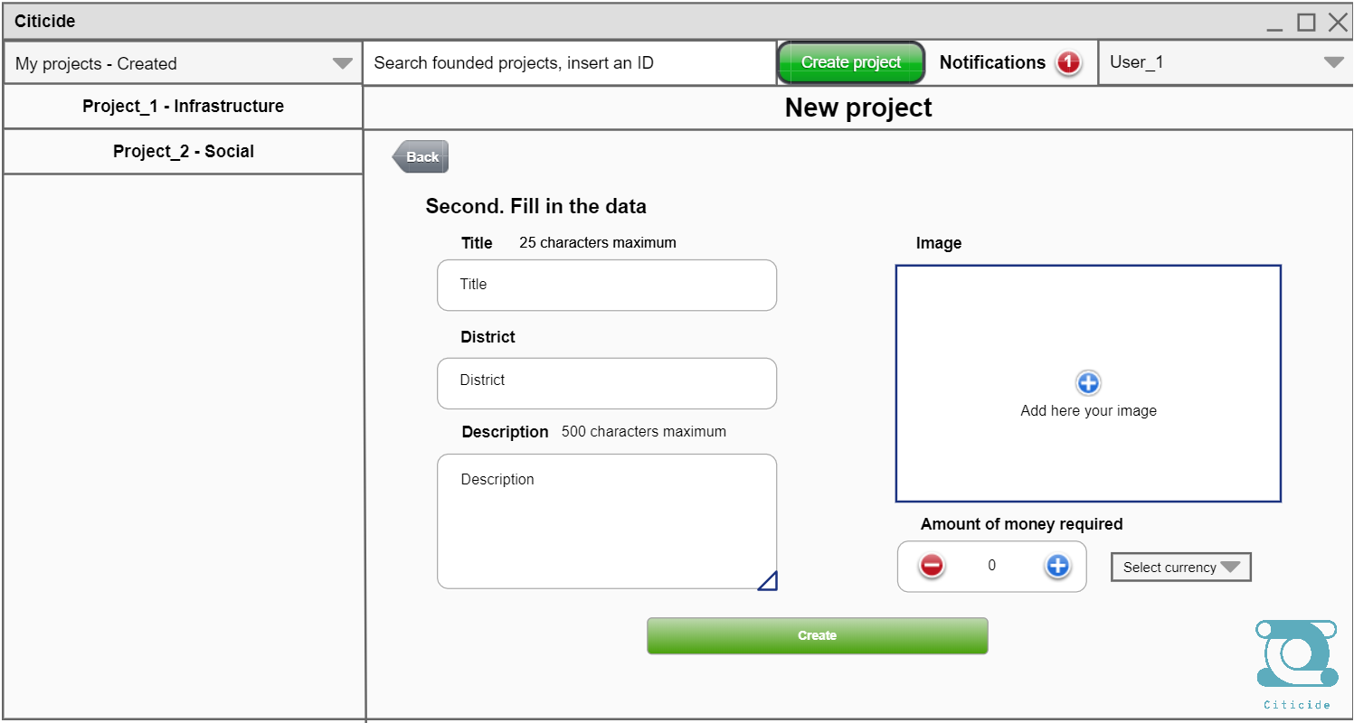
Buttons for increasing or decreasing the number (We can also write in this box)
Button for adding the image
Combo box
Figure 10
Button for going back

If the we select the “Social” category in Figure 9:

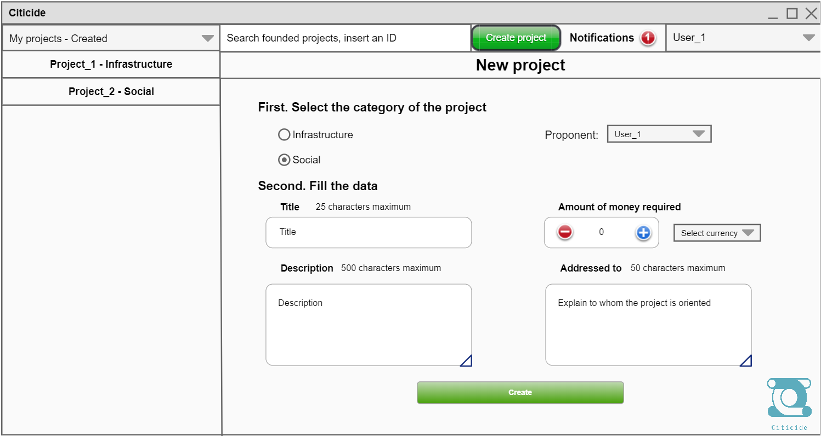
Figure 11

Then, if choose on the upper left combo box the option “My projects - Pending”, we can see the projects that we have created, but the administrator has not admitted or rejected yet.

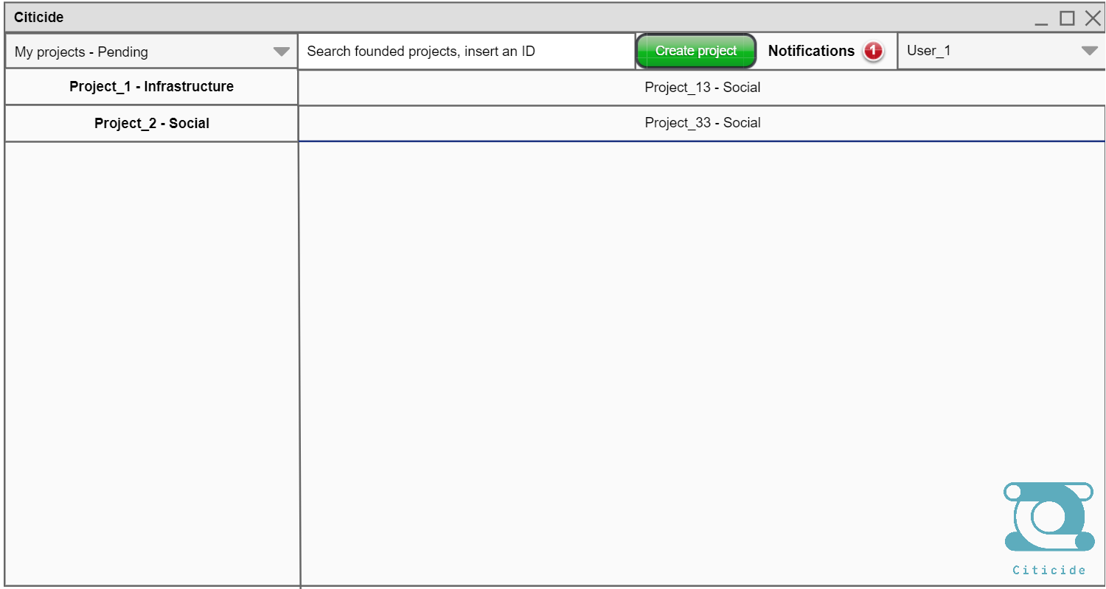
Figure 12

If choose on the upper left combo box the option “Voted projects”, we can see the projects that we have voted, the way we have done this action and its different information.
If we have voted as member of a group and individually:

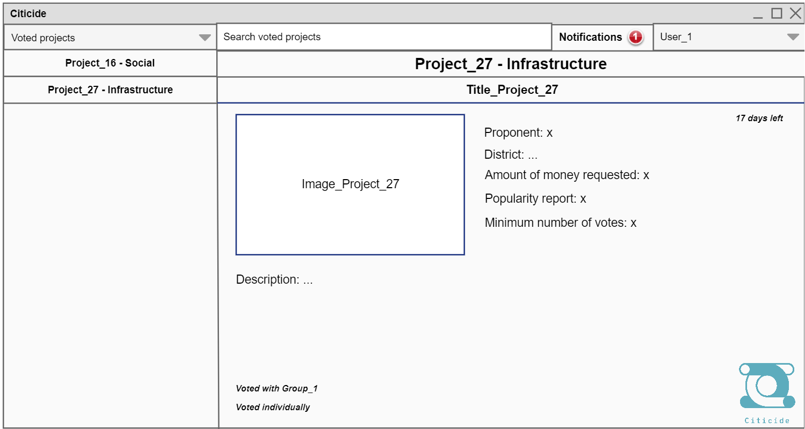
Figure 13.1

If we have voted as manager of a group and individually:

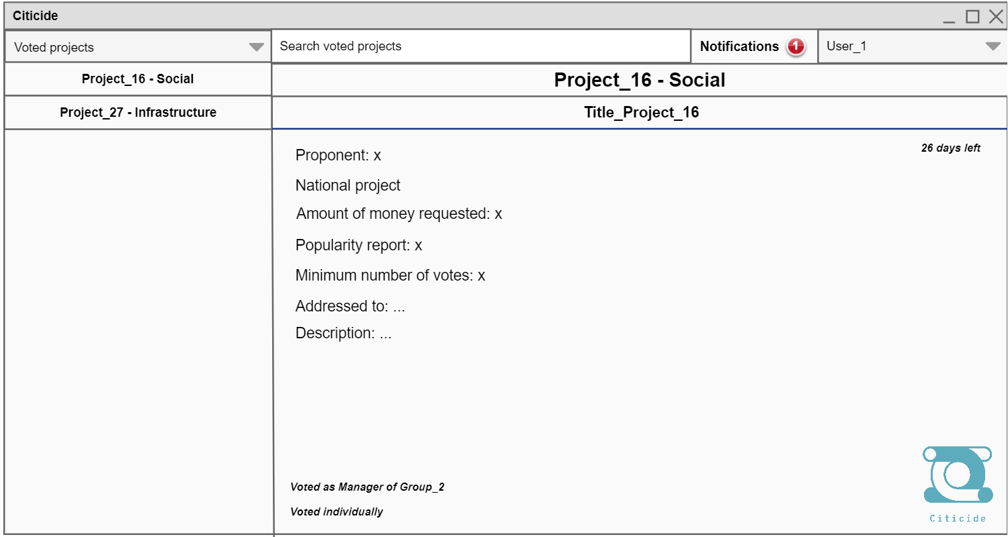
Figure 13.2

If in any of the last Figures, except for 1 and 2, we click on “Notifications”, we can see the messages received.

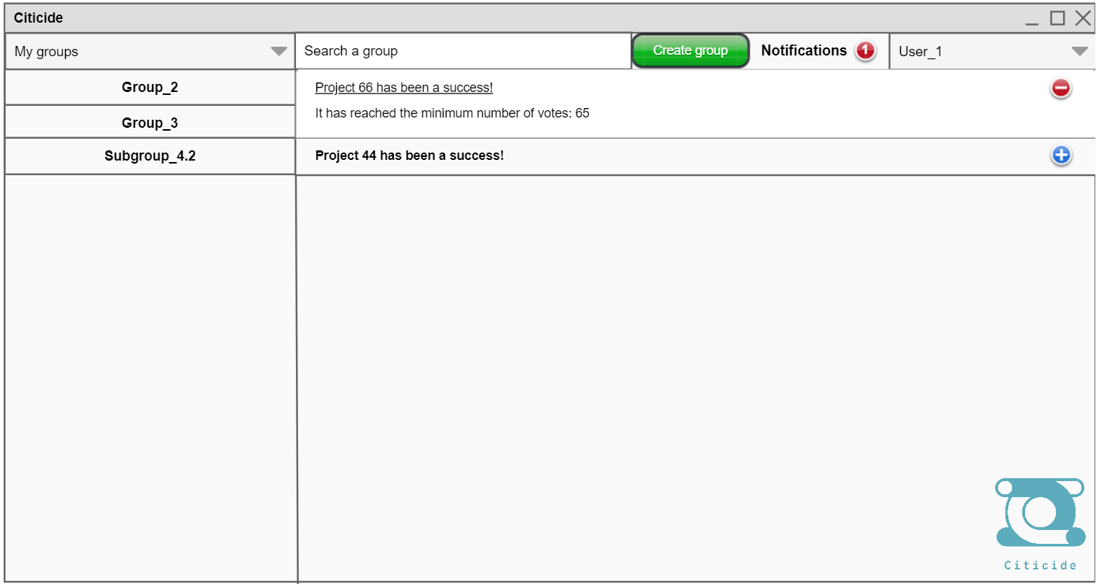
Button for hiding the notification
Button for expanding the notification
Figure 14

Now, we are going to see the administrator windows. When he enters, the following page is displayed, where he can admit or reject a project, and in case it is admitted, he enters the minimum number of votes.

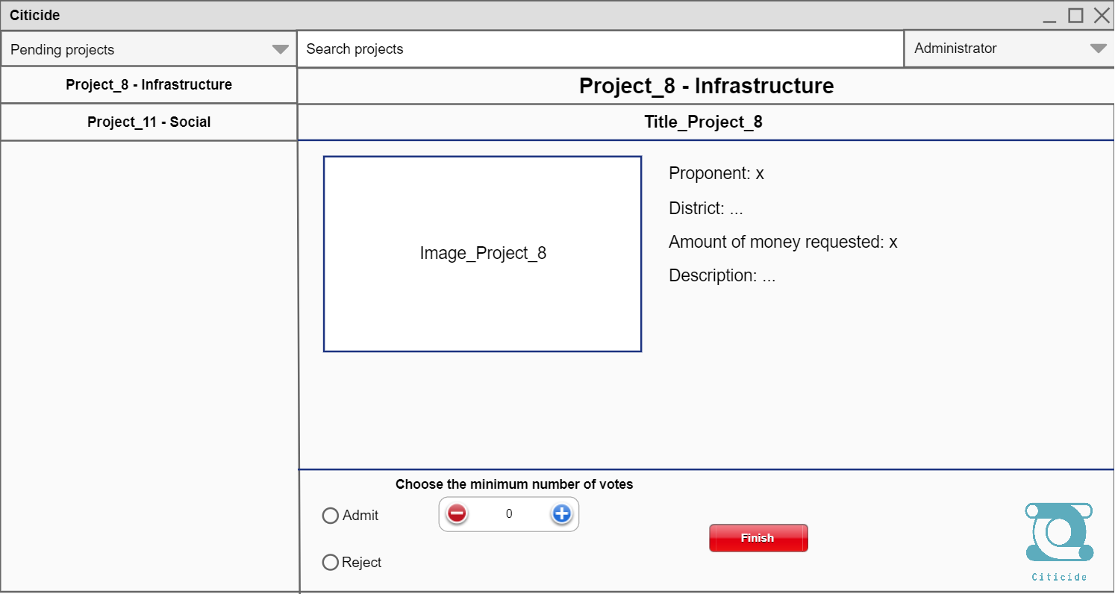
Figure 15

If the administrator chooses the “Pending users (New)” option on the upper left combo box, he then can select the users. Once he has selected someone, he can authorize or reject him.

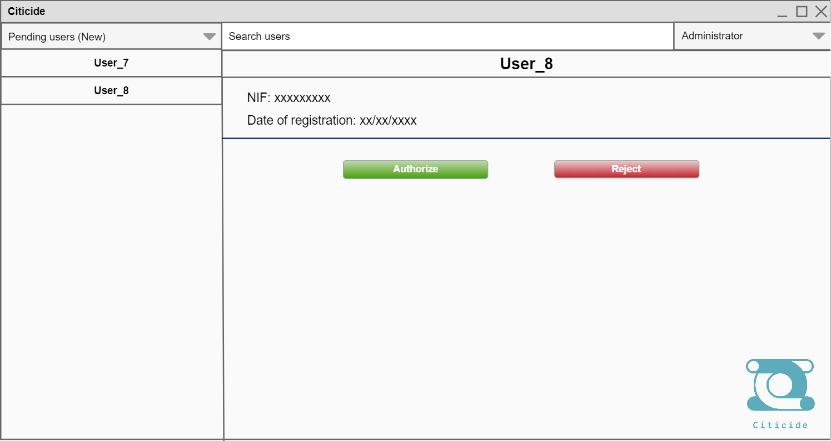
Figure 16

If the option “Users – Active” is chosen on the upper left combo box, the administrator can choose the user he wants to ban and writes the reason for this action.

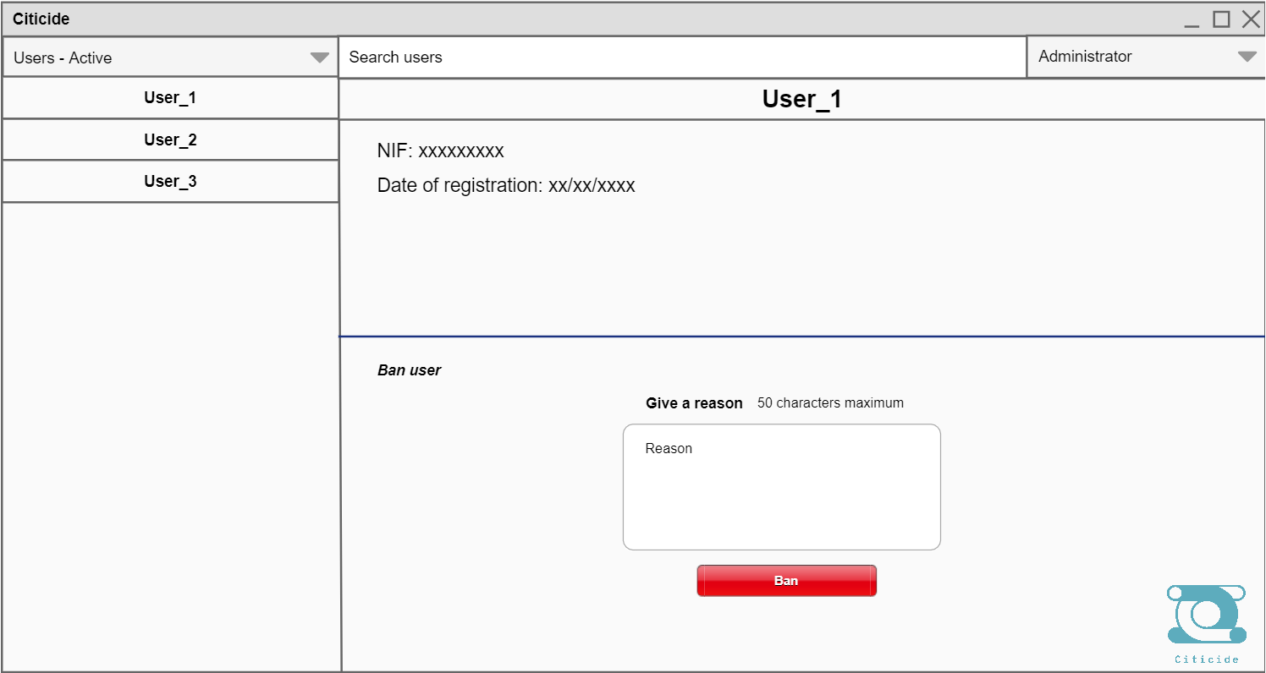
Figure 17

If the option “Users – Banned” is chosen on the upper left combo box, the administrator can choose the user he wants to unban.

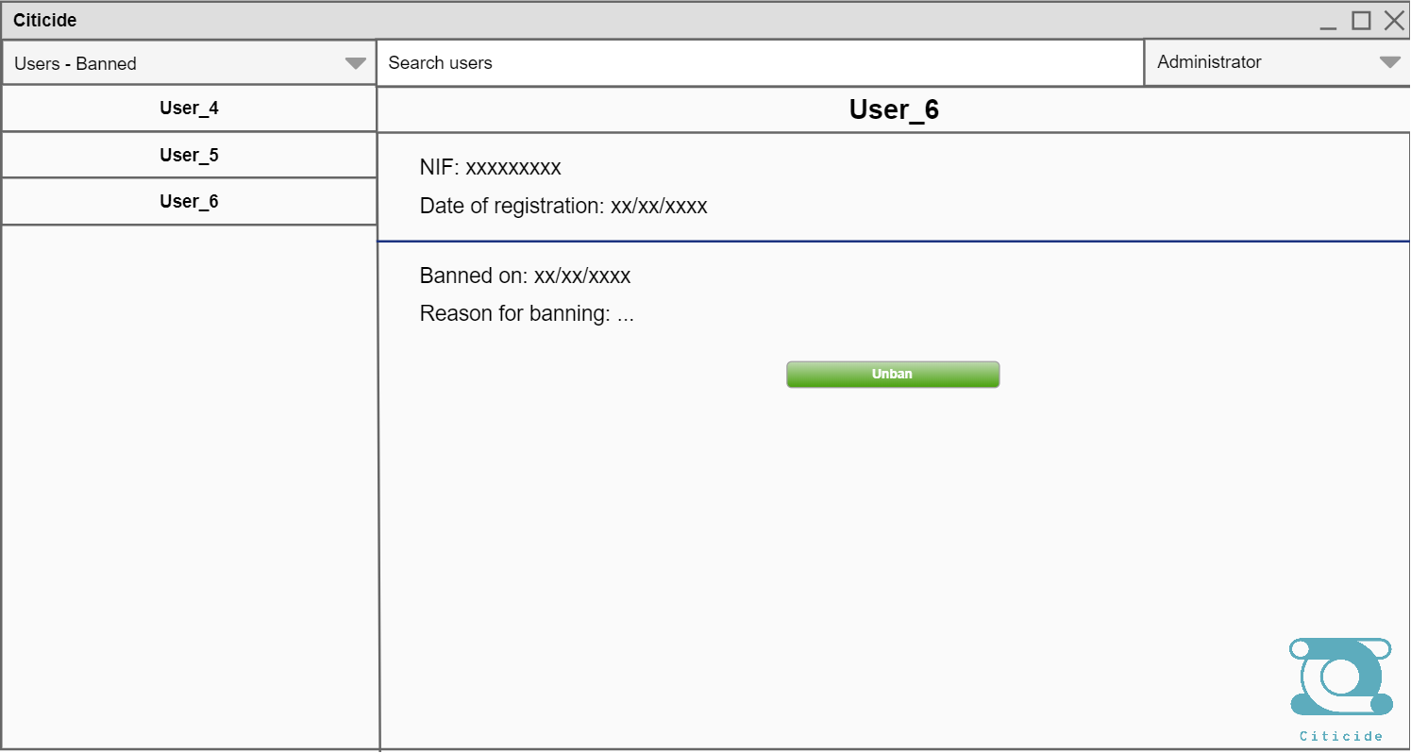
Figure 18

